**DEPARTMENT OF TECHNICAL EDUCATION**

**BOARD OF TECHNICAL EXAMINATIONS**

**BANGALORE**



**PROJECT REPORT**

**ON**

**“WIRELESS NOTICE BOARD”**

**Submitted by**

**GURUPRASADA S HEGDE 327EC16009**

**FAROOQ AHMED 327EC16006**

**NAGARATNA N NAIK 327EC16015**

**PRASHANT C A 327EC16201**

**SUMANT BHAT 327EC15035**

**Under the Guidance of**

**SHEELA H.B.**

**[ Lecturer, Dept of E&C, R.N.S.P.T. Sirsi ]**



**Department of Electronics and Communication Engineering**

**M.E.S.R.N.SHETTY POLYTECHNIC**

**SIRSI-581402**

**DEPARTMENT OF TECHNICAL EDUCATION**

**M.E.S. R.N.SHETTY POLYTECHNIC**

**SIRSI-581402**

**DEPARTMENT OF ELECTRONICS AND COMMUNICATION**

**CERTIFICATE**

This is to certify that the project entitled**" WIRELESS NOTICE BOARD"**Which is being submitted by **Mr.GURUPRASADA S HEGDE, Mr.FAROOQ AHMED, Ms.NAGARATNA N NAIK, Mr.PRASHANT C A, Mr.SUMANT BHAT** are benefited students of**R.N.SHETTY POLYTECHNIC** in partial fulfillment for the award of Diploma in**Electronics and Communication Engineering** during the year 2018-2019 is records of students own work carried out under the guidance. It is certified that all correction/suggestions indicated for internal assessment have been incorporated in the report and one copy of it being deposited in the polytechnic library. The project report has been approved as it satisfies the academic requirements in the respect of project work prescribed for diploma...

It is further understood that by this certificate the undersigned do not endorse or approve any statement made, opinion expressed or conclusion drawn there.

**Signature of Principal Signature of HOD**

**Signature of Guide**: **Signature of Examiners**

**1.**

**2.**

**ACKNOWLEDGEMENT**

We would like to express our gratitude to the following people whose constant support helped immensely in the successful completion of our project

We would like to thank Shri **Nityanand Kini,**the**Principal** of R.N.S polytechnic Sirsi for providing such a congential working environment.

We are also grateful to **Shri Venkatagiri Hedge,HOD,E&C Department** , R.N.S polytechnic Sirsi, for the excellent support in terms of resources provided and for their continuous motivation and support,practica work and for providing us with necessary ideas whenever required.

We sincerely thank our project guide, **Ms.Sheela H.B.**lecturer,E&C Department R.N.S. Polytechnic Sirsi, for their support and encouragement.

Finally we would like to thank our parents and all the teaching and non teaching staff of the Department of Electronics and Communication Engineering for all the help provided.

**GURUPRASADA S HEGDE 327EC16009**

**FAROOQ AHMED 327EC16006**

**NAGARATNA N NAIK 327EC16015**

**PRASHANT C A 327EC16201**

**SUMANT T BHAT 327EC15035**

**THE STUDENT’S DECLERATION**

WE are **GURUPRASADA S HEGDE,FAROOQ AHMED, NAGARATNA N NAIK, PRASHANT C A, SUMANT BHAT,**the students of **Diploma in Electronics and Communication Department** bearing of M.E.S.R.N.S**. POLYTECHNIC Sirsi**, hereby declare that we own full responsibility for the information, results and conclusion provided in this project work titled " **WIRELESS NOTICE BOARD**" submitted to the **Board of Technical Examinations,Government Of Karnataka** for the award of Diploma.

To the best of my knowledge, this project work has not been submitted in part or full elsewhere in any other institution/organization for award of any certificate/diploma/degree. We have completely taken care of acknowledging the contribution of others in this academic work, We further declared that in case of any violation of intellectual property rights and particulars declared, found at any stage we as the candidate will solely responsible for the same.

**Date:**

**Place: Sirsi**

**GURUPRASADA S HEGDE**

**FAROOQ AHMED**

**NAGARATNA N NAIK**

**PRASHANT C A**

**SUMANT T BHAT**

**ABSTRACT**

This document deals with an innovative rather an interesting manner of intimating the message to the people using a wireless electronic display board which is synchronized using the Bluetooth technology. This will help us in passing any message almost immediately without any delay just by sending a message from android application which is better and more reliable than the old traditional way of passing the message on notice board. This proposed technology can be used in colleges many public places, malls or big buildings to enhance the security system and also make awareness of the emergency situations and avoid many dangers.Now a day’s every advertisement is going to be digital. The big shops and shopping centers are using the digital moving displays now. In Railway station and bus stands everything that is ticket information, platform number etc is displaying in digital moving display. But in these displays if they wants to change the message or style they have to go there and connect the display to PC or laptop.Notice Board is primary thing in any institution / organization or public utility places like bus stations, railway stations and parks. But sticking various notices day-to-day is a difficult process. A separate person is required to take care of this notices display. This project deals about an advanced hi-tech wireless notice board. An embedded system is a combination of software and hardware to perform a dedicated task. Using Bluetooth module display the message onto the display board.This system enhances the accuracy and display the message in well known manner.

**CONTENTS**

**Page No.**

**CHAPTER 1:INTRODUCTION**

* 1. Problem Statement

1.2 Project Objectives

1.3 Literature Survey

1.4 Significance

1.5 Scope

1.6 About the Project

**CHAPTER 2:STUDY AREA**

2.1 Arduino UNO

2.2 DMD Matrix Display

2.3 Ribbon Cable connector

2.4 SMPS Based Adapter

2.5 HC 06 Bluetooth Module

**CHAPTER 3:IMPLEMENTATION**

**3.1** Interfacing diagram and working

3.2 Software design:Flow chart

**CHAPTER 4:ADVANTAGES & APPLICATIONS**

**CHAPTER 5:RESULTS & CONCLUSION**

5.1 Tests And Results

5.2 Conclusion

5.3 Feature scope

**BIBLIOGRAPHY**

**APPENDICES**

APPENDIX-A: RS23 Standards

APPENDIX-B: MAX 232

APPENDIX-C: Geting started with Arduino IDE

**LIST OF FIGURES:**

|  |  |  |  |
| --- | --- | --- | --- |
| **SL. No.** | **Figure No.** | **Description** | **Page No.** |
| 1 | Figure 1.1 | Block diagram of Wireless Notice Board |  |
| 2 | Figure 2.1 | Arduino UNO |  |
| 3 | Figure 2.2 | Pin configuration |  |
| 4 | Figure 2.3 | Dot matrix Display |  |
| 5 | Figure 2.4 | Back pane of dmd |  |
| 6 | Figure 2.5 | Connector and pinout |  |
| 7 | Figure 2.6 | Smps lookout |  |
| 8 | Figure 3.1 | Hc 06 bluetooth module |  |
| 9 | Figure 3.2 | Interfacing of arduino with dmd |  |
| 10 | Figure 3.3 | Interfacing of arduino with hc 06 bluetooth module |  |
| 11 | Figure 3.4 | Flow chart of procesing |  |
| 12 | Figure A1 | Flow chart of android app execution |  |
| 13 | Figure A2 | Pin assignment |  |
| 14 | Figure A3 | Db9 connector |  |
| 15 | Figure B1 | Usb to serial cable |  |
| 16 | Figure B2 | Max 232 |  |
| 17 | Figure C1 | Max 232 circuit |  |
| 18 | Figure C2 | Creating new project |  |
| 19 | Figure C3 | Project code configuration |  |
| 20 | Figure C4 | Loading Zip.liberary,compiling,uploading |  |

LIST OF TABELS:

|  |  |  |  |
| --- | --- | --- | --- |
| **SL NO.** | **Table No.** | **Description** | **Page No.** |
| 1 | A2 | DB9 Pin Details |  |
| 2 | B3 | Voltage level of MAX232 |  |

**CHAPTER 1:**

**INTRODUCTION**

* 1. **PROBLEM STATEMENT:**

Paper consumption is the superlative reason for forest degradation and notice is an indispensable requirement for public places, organization to get connect/ communicate with people in one way or both. Since there are many easy configurable, low power consuming wireless technologies (like Wi-Fi, Bluetooth, RF, XBEE, GSM) are available, a wireless electronic notice board system can be easily realized by using any of them replacing the need of paper notice board. Since the world is stepping towards digitization the need for wireless digital notice board is found. Wireless e-notice board is a perfect replacement of paper notice board providing easy maintenance, portability and access.

* 1. **PROJECT OBJECTIVES**

The wired communication faces a lot of shortcomings such as need of hard wiring, BER (bit error rate) at high transmission speed due to wire line capacitance, high cost, high maintenance and short coverage. Wireless communication systems have made a significant move to overcome such problems. Bluetooth, RF, Xbee, WI - Fi and GSM, are easily available wireless technologies suitable for short, medium and long range wireless communication. A method of updating digital notice board through BLUETOOTH via Android application is described. It emphasizes the method of transmitting a notice in the form of Application via mobile and receiving that message by microcontroller through BLUETOOTH module hardware and displaying the received message. Since it uses the BLUETOOTH as wireless mediator . Bluetooth based wireless electronic notice board prototype approach is described.

* 1. **LITERATURE SURVEY**

In present state this system lacks software,time consumed in accessing the message,manual creation,traditional boards which compex the system by wires and there is no automatic criteria.But after implementation it comes with wireless,android app control,easy to use and automatic operation without any delay .Manual operation by the person by sticking various notices is difficut in day to day life. This project deals with advanced hi-tech technology to save the time energy and finally environment.

* 1. **SIGNIFICANCE:**

The system is comprised of both software and hardware. Software area includes the Bluetooth android application development and code algorithm for microcontroller to receive and display a notice on graphical liquid crystal display. The hardware area includes the development of receiver hardware using ATmega32 microcontroller and its configuration with both modules. The developed system reflects the minimum requirements to realize the wireless notice board. The system has the following sections-

1. Bluetooth Communication
2. Bluetooth Module and Connection
3. System Integration
4. Arduino interfacing to Display
   1. **SCOPE**:

It is not like traditional system.The developed system reflects the minimum requirements to realize the wireless notice board.Notice boards are extensively used in daily life .It plays the major role in public places,organisations etc.This modern proposed solution used for many applications .Wireless and android control gives easy user interface with minimum complexities.Bluetooth technology which enhances the security and DMD dispay having higher accuracy with low power consumption.This system will not introduces delay during operation.

* 1. **ABOUT THE PROJECT:**

We have been using notice boards to display messages in offices, schools hospitals etc. from a long time. But the major problem with these notice boards are every time we need to change the message we have to go there and then erase previous message and then write the new one. So this project is a solution to this problem as it wireless technology Bluetooth which provides us the facility to change message on notice boards from distant mobile phone that is operated on android OS to do the same a application is built with the graphical interface to change the message.

**1.6.1 BLOCK DIAGRAM:**

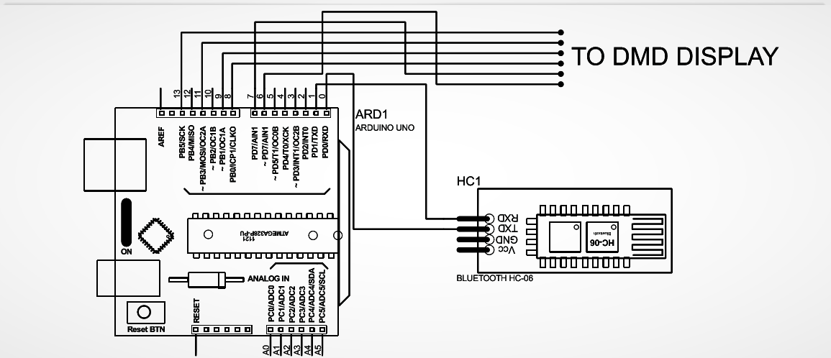

**Figure 1.1:** Block Diagram of Wireless Notice Board

**CHAPTER 2**:

**STUDY AREA**

In This chapter we will study about the different components used in the project “wireless notice board” . they are arduinouno , Hc 06 bluetooth module , 32\*16 dmd display, 5v 5A SMPS adapter, heat sink, 7805 IC, Ribbon cable connector.

**2.1Arduino UNO :**

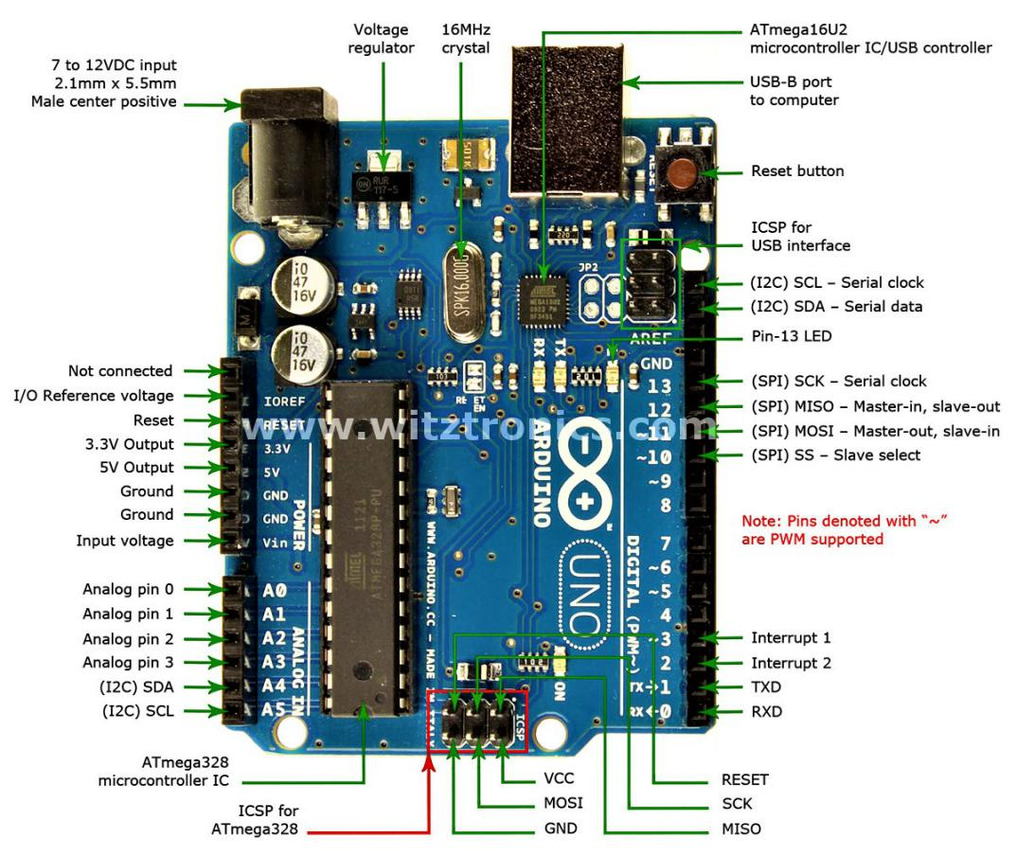

**Figure 2.1:** Arduino UNO

**Overview**

The Arduino Uno is a microcontroller board based on the ATmega328 (datasheet). It has 14 digital input/output pins (of which 6 can be used as PWM outputs), 6 analog inputs, a 16 MHz ceramic resonator, a USB connection, a power jack, an ICSP header, and a reset button. It contains everything needed to support the microcontroller; simply connect it to a computer with a USB cable or power it with a AC-to-DC adapter or battery to get started. The Uno differs from all preceding boards in that it does not use the FTDI USB-to-serial driver chip. Instead, it features the Atmega16U2 (Atmega8U2 up to version R2) programmed as a USB-to-serial converter. Revision 2 of the Uno board has a resistor pulling the 8U2 HWB line to ground, making it easier to put into DFU mode. Revision 3 of the board has the following new features:

• 1.0 pinout: added SDA and SCL pins that are near to the AREF pin and two other new pins placed near to the RESET pin, the IOREF that allow the shields to adapt to the voltage provided from the board. In future, shields will be compatible both with the board that use the AVR, which operate with 5V and with the Arduino Due that operate with 3.3V. The second one is a not connected pin, that is reserved for future purposes Stronger RESET circuit. Atmega 16U2 replace the 8U2. "Uno" means one in Italian and is named to mark the upcoming release of Arduino 1.0. The Uno and version 1.0 will be the reference versions of Arduino, moving forward. The Uno is the latest in a series of USB Arduino boards, and the reference model for the Arduino platform; for a comparison with previous versions, see the index of Arduino boards.

**Summary**

Microcontroller ATmega328 Operating Voltage 5V Input Voltage (recommended) 7-12V Input Voltage (limits) 6-20V Digital I/O Pins 14 (of which 6 provide PWM output) Analog Input Pins 6 DC Current per I/O Pin 40 mA DC Current for 3.3V Pin 50 mA Flash Memory 32 KB (ATmega328) of which 0.5 KB used by bootloader SRAM 2 KB (ATmega328) EEPROM 1 KB (ATmega328) Clock Speed 16 MHz.

**Schematic & Reference Design**

EAGLE files: arduino-uno-Rev3-reference-design.zip (NOTE: works with Eagle 6.0 and newer) Schematic: arduino-uno-Rev3-schematic.pdf Note: The Arduino reference design can use an Atmega8, 168, or 328, Current models use an ATmega328, but an Atmega8 is shown in the schematic for reference. The pin configuration is identical on all three processors.

**Power**

The Arduino Uno can be powered via the USB connection or with an external power supply. The power source is selected automatically. External (non-USB) power can come either from an AC-to-DC adapter (wall-wart) or battery. The adapter can be connected by plugging a 2.1mm center-positive plug into the board's power jack. Leads from a battery can be inserted in the Gnd and Vin pin headers of the POWER connector. The board can operate on an external supply of 6 to 20 volts. If supplied with less than 7V, however, the 5V pin may supply less than five volts and the board may be unstable. If using more than 12V, the voltage regulator may overheat and damage the board. The recommended range is 7 to 12 volts. The power pins are as follows:

**VIN**. The input voltage to the Arduino board when it's using an external power source (as opposed to 5 volts from the USB connection or other regulated power source). You can supply voltage through this pin, or, if supplying voltage via the power jack, access it through this pin.

**5V**.This pin outputs a regulated 5V from the regulator on the board. The board can be supplied with power either from the DC power jack (7 - 12V), the USB connector (5V), or the VIN pin of the board (7-12V). Supplying voltage via the 5V or 3.3V pins bypasses the regulator, and can damage your board. We don't advise it.

**3V3.** A 3.3 volt supply generated by the on-board regulator. Maximum current draw is 50 mA.

**GND.** Ground pins.

**Memory**

The ATmega328 has 32 KB (with 0.5 KB used for the bootloader). It also has 2 KB of SRAM and 1 KB of EEPROM (which can be read and written with the EEPROM library).

**Input and Output**

Each of the 14 digital pins on the Uno can be used as an input or output, using pinMode(), digitalWrite(), and digitalRead() functions. They operate at 5 volts. Each pin can provide or receive a maximum of 40 mA and has an internal pull-up resistor (disconnected by default) of 20-50 kOhms. In addition, some pins have specialized functions:

**Serial:** 0 (RX) and 1 (TX). Used to receive (RX) and transmit (TX) TTL serial data. These pins are connected to the corresponding pins of the ATmega8U2 USB-to-TTL Serial chip.

**External Interrupts:** 2 and 3. These pins can be configured to trigger an interrupt on a low value, a rising or falling edge, or a change in value. See the attachInterrupt() function for details. **PWM**: 3, 5, 6, 9, 10, and 11. Provide 8-bit PWM output with the analogWrite() function.

**SPI:** 10 (SS), 11 (MOSI), 12 (MISO), 13 (SCK). These pins support SPI communication using the SPI library.

**LED: 13.** There is a built-in LED connected to digital pin 13. When the pin is HIGH value, the LED is on, when the pin is LOW, it's off.

The Uno has 6 analog inputs, labeled A0 through A5, each of which provide 10 bits of resolution (i.e. 1024 different values). By default they measure from ground to 5 volts, though is it possible to change the upper end of their range using the AREF pin and the analogReference() function. Additionally, some pins have specialized functionality:

**TWI**: A4 or SDA pin and A5 or SCL pin. Support TWI communication using the Wire library.

There are a couple of other pins on the board:

**AREF**. Reference voltage for the analog inputs. Used with analogReference(). • Reset. Bring this line LOW to reset the microcontroller. Typically used to add a reset button to shields which block the one on the board.

**2.1.1 PIN CONFIGURATION:**

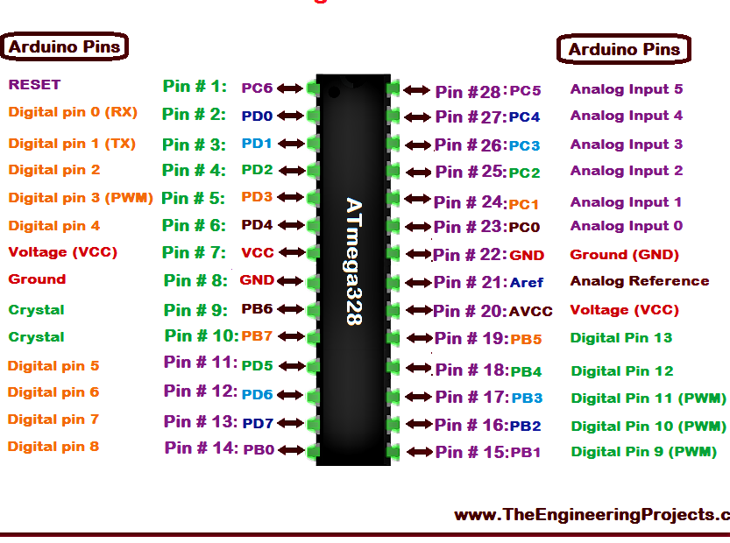 **Figure 2.2** Pin configuration of ATMEGA328

**2.1.2 PIN DESCRIPTION**

In this article, we will go over the pinout of the Atmega328 chip.The Atmega328 is a very popular microcontroller chip produced by Atmel. It is an 8-bit microcontroller that has 32K of flash memory, 1K of EEPROM, and 2K of internal SRAM.As stated before, 20 of the pins function as I/O ports. This means they can function as an input to the circuit or as output. Whether they are input or output is set in the software. 14 of the pins are digital pins, of which 6 can function to give PWM output. 6 of the pins are for analog input/output. The Atmega328 has 28 pins.It has 14 digital I/O pins, of which 6 can be used as PWM outputs and 6 analog input pins. These I/O pins account for 20 of the pins.2 of the pins are for the crystal oscillator. This is to provide a clock pulse for the Atmega chip. A clock pulse is needed for synchronization so that communication can occur in synchrony between the Atmega chip and a device that it is connected to.The chip needs power so 2 of the pins, Vcc and GND, provide it power so that it can operate. The Atmega328 is a low-power chip, so it only needs between 1.8-5.5V of power to operate.The Atmega328 chip has an analog-to-digital converter (ADC) inside of it. This must be or else the Atmega328 wouldn't be capable of interpreting analog signals. Because there is an ADC, the chip can interpret analog input, which is why the chip has 6 pins for analog input. The ADC has 3 pins set aside for it to function- AVCC, AREF, and GND. AVCC is the power supply, positive voltage, that for the ADC. The ADC needs its own power supply in order to work. GND is the power supply ground. AREF is the reference voltage that the ADC uses to convert an analog signal to its corresponding digital value. Analog voltages higher than the reference voltage will be assigned to a digital value of 1, while analog voltages below the reference voltage will be assigned the digital value of 0. Since the ADC for the Atmega328 is a 10-bit ADC, meaning it produces a 10-bit digital value, it converts an analog signal to its digital value, with the AREF value being a reference for which digital values are high or low. Thus, a portrait of an analog signal is shown by this digital value; thus, it is its digital correspondent value.The last pin is the RESET pin. This allows a program to be rerun and start over.And this sums up the pinout of an Atmega328 chip. The Atmega328 is one of the microcontroller chips that are used with the popular ArduinoDuemilanove boards. The ArduinoDuemilanove board comes with either 1 of 2 microcontroller chips, the Atmega168 or the Atmega328. Of these 2, the Atmega328 is the upgraded, more advanced chip. Unlike the Atmega168 which has 16K of flash program memory and 512 bytes of internal SRAM, the Atmega328 has 32K of flash program memory and 2K of Internal SRAM.

2.2 **Dot Matrix Display :**

**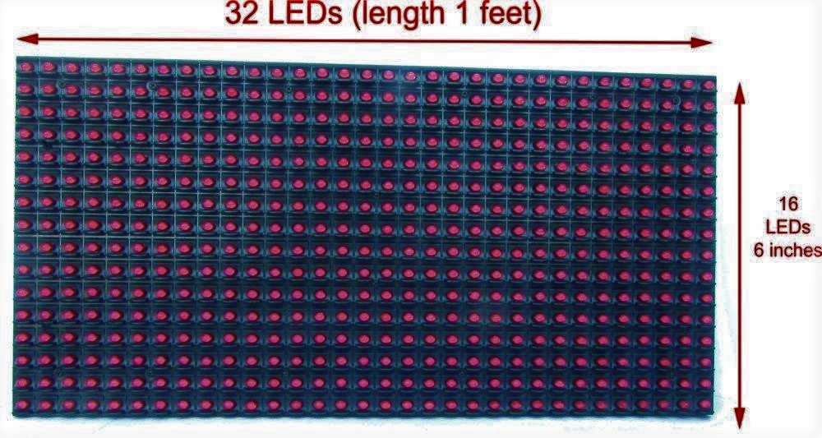**

**Figure 2.3** Dot Matrix Display

**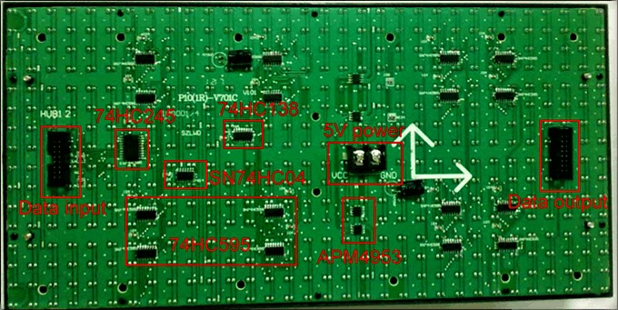**

**Figure 2.4** Back panel of DMD

**Getting Started with your Dot Matrix Display (DMD)**

The DMD is a huge dot matrix LED display panel to connected to any Arduino compatible board. This large, bright 512 LED matrix panel has on-board controller circuitry designed to make it easy to use straight from your board's control pins. Clocks, status displays, graphics readouts and all kinds of impressive display projects are ready to create with this display’s features.

● 32 columns x 16 rows of high brightness Red LEDs (512 LEDs in total) on a 10mm pitch

● 5V operation

● Viewable over 12 metres away

● Tough plastic frame

● Controller IC’s on board, simple clocked data interface

● Arduino compatible library, graphics functions and examples on our site

● Dimensions: 320(W) x 160(H) x 14(D)mm (30mm(D) including rear connectors)

The DMD is provided with a support library created by us for displaying text in different fonts, drawing graphics, lines, circles, rectangles and more when connected to any Arduino compatible board.

Included in your DMD package is:

● The 512 LED Dot Matrix Display (DMD)

● A 16 pin (2x8) IDC ribbon cable for DMD connection

● An optional 5V power cable to use if jumping power to DMD's stacked on top of each other

**Installation of your DMD**

1. Turn the DMD over so that the PCB is facing you and the "UP" arrow is pointing away from you.

2. Connect the ribbon cable to the DMD connector on the left side. The connector on the right side is to allow more DMD's to be connected to make larger combined displays. The red stripe (pin 1) on the ribbon cable should be towards the "UP" side of the rear of the DMD. The DMD has an "UP" marker on the back and an arrow facing upwards, to assist in the display and cable directions.

3. Connect the other end of the ribbon cable to the DMDCON board. The location of the red stripe and connector direction is clearly marked on the DMDCON board.

4. Plug the DMDCON board into your Arduino board. The DMDCON board is designed to plug straight into the Arduino headers with AREF on the left and D6 on the right. You can see the pin markings on the DMDCON board to match with your Arduino board pin markings if needed.

5. That's it! Your DMD is connected to your Arduino board.

At this point you can run the DMD from our downloaded library and examples even though it has no 5V power connected to the DMD terminals, as the data lines feed weak power to the LEDs. It's a handy way to develop and play with your DMD graphics and display project.

6. If or when you want the DMD to be very bright and the LEDs fully powered, connect a strong, stable 5V supply that is capable of at 4 to 40 Amps of current at 5V DC (regulated) to the large VCC (5V) and GND terminal block. The current used is proportional to how many LEDs are lit in the display.

If all 512 LEDs are lit, the DMD is capable of drawing some rather high currents from the 5V rail! We recommend that for high brightness, high power use where most or all LEDs are lit, that an ATX PC power supply or similar is used to power the 5V rail. Do not use 5V from your Arduino or USB power to power the high brightness DMD 5V input terminals directly as those sources are only capable of 0.5A at best.If connecting separate 5V power to your DMD terminals while connected to your Arduino board by USB, be very careful of your external 5V power source polarity as you may feed damaging reverse voltage to your computer's USB port, should the wires be reversed or ground offset.

**2.3 Ribbon Cable Connector**

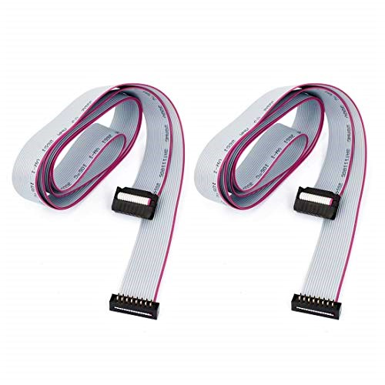 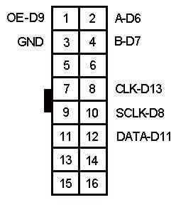

**Figure 2.5** Connector and pinout

A **ribbon cable** (also known as multi-wire planar cable) is a cable with many conducting wires running parallel to each other on the same flat plane. As a result the cable is wide and flat. Its name comes from its resemblance to a piece of [ribbon](https://en.wikipedia.org/wiki/Ribbon" \o "Ribbon).[[1]](https://en.wikipedia.org/wiki/Ribbon_cable" \l "cite_note-Ribbon-and-Flat-Cable-Assemblies-whitepaper.pdf-1)

Ribbon cables are usually seen for internal peripherals in [computers](https://en.wikipedia.org/wiki/Computer" \o "Computer).

To reduce the risk of reversed connections one edge of the cable is usually marked with a red stripe.

**2.4 SMPS Based Adapter**

**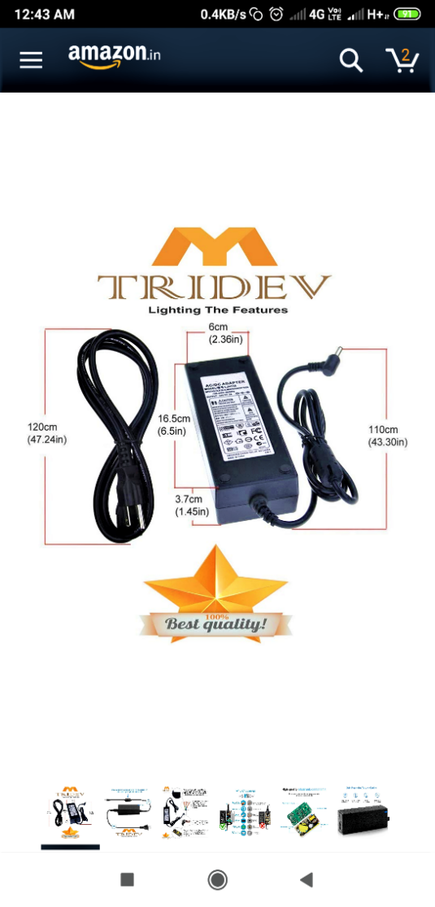 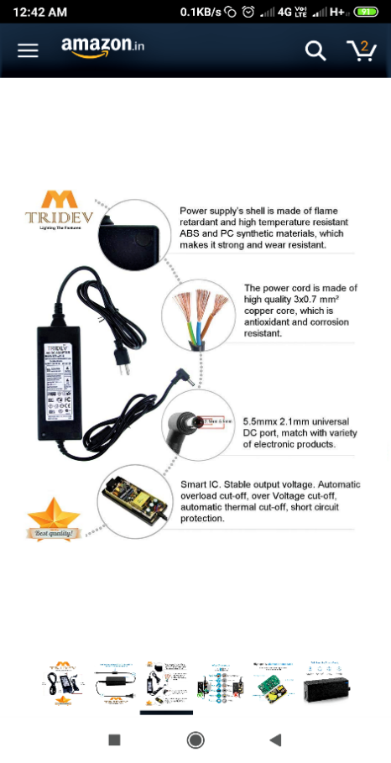**

**Figure** 2.6 SMPS lookout

Above figure shows 5V 5A SMPS used as a power source for the system.

A **switched-mode power supply** (**switching-mode power supply**, **switch-mode power supply**, **switched power supply**, **SMPS**, or **switcher**) is an electronic [power supply](https://en.wikipedia.org/wiki/Power_supply" \o "Power supply) that incorporates a [switching regulator](https://en.wikipedia.org/wiki/Voltage_regulator" \l "Switching_regulators" \o "Voltage regulator) to [convert electrical power](https://en.wikipedia.org/wiki/Electrical_power_conversion" \o "Electrical power conversion) efficiently. Like other power supplies, an SMPS transfers power from a DC or AC source (often [mains power](https://en.wikipedia.org/wiki/Mains_electricity" \o "Mains electricity)) to DC loads, such as a [personal computer](https://en.wikipedia.org/wiki/Personal_computer" \o "Personal computer), while converting [voltage](https://en.wikipedia.org/wiki/Voltage" \o "Voltage) and [current](https://en.wikipedia.org/wiki/Electric_current" \o "Electric current) characteristics. Unlike a [linear power supply](https://en.wikipedia.org/wiki/Linear_power_supply" \o "Linear power supply), the pass transistor of a switching-mode supply continually switches between low-[dissipation](https://en.wikipedia.org/wiki/Dissipation" \o "Dissipation), full-on and full-off states, and spends very little time in the high dissipation transitions, which minimizes wasted energy.

**Specifications**

* Stabalized output
* Short circuit and overload protection
* Thermal protection
* Lightning proof
* Over voltage and current protection
* High efficiency and low energy consumption
* High integrated smps switcher ic
* Led indicator

**2.5 HC 06 Bluetooth module :**

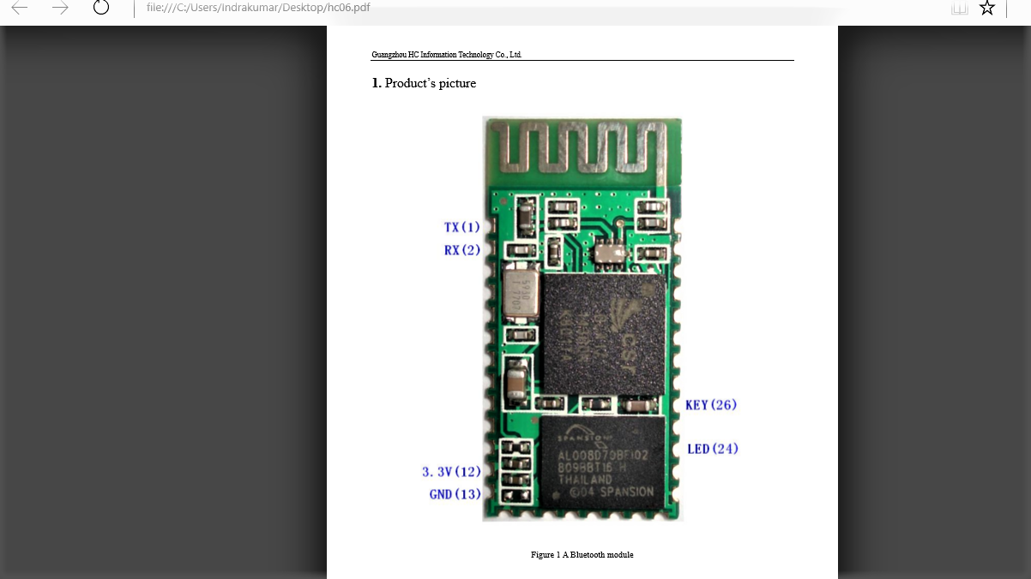

**Figure 2.7** HC-06 Bluetooth module

**Features**

* **Wireless transceiver**
* Sensitivity (Bit error rate) can reach -80dBm.
* **Function description (perfect Bluetooth solution)**
* Has an EDR module; and the change range of modulation depth: 2Mbps 3Mbps.
* Has a build-in 2.4GHz antenna; user needn’t test antenna.
* Has the external 8Mbit FLASH
* Can work at the low voltage (3.1V~4.2V). The current in pairing is in the range of 30～40mA. The current in communication is 8mA.
* Standard HCI Port (UART or USB)
* USB Protocol: Full Speed USB1.1, Compliant With 2.0
* It’s made through RoHS process.
* Has a 2.4GHz digital wireless transceiver.
* Bases at CSR BC04 Bluetooth technology.

➢

**CHAPTER 3**

**IMPLEMENTATION**

**INTERFACING DIAGRAM :**

**Interfacing of Arduino UNO with DMD display**

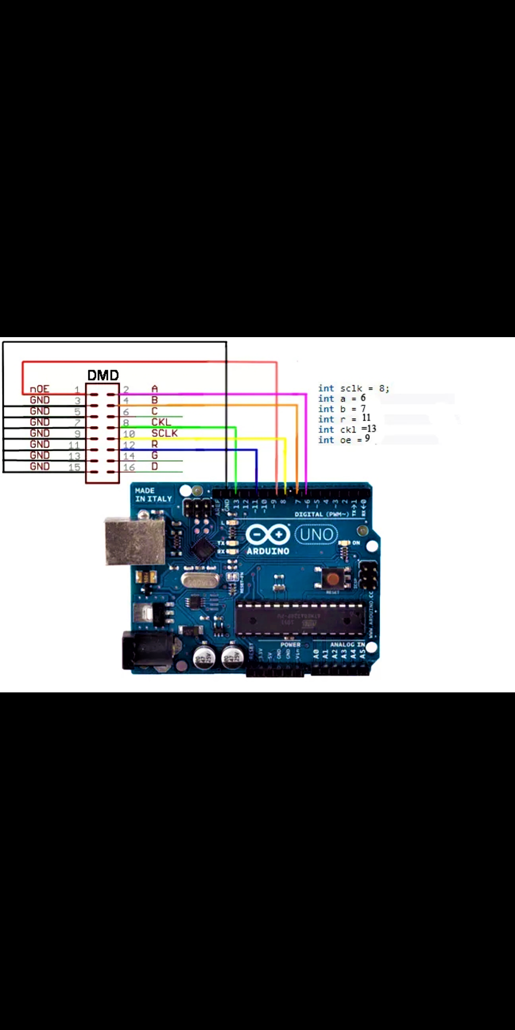

**Figure 3.1** interfacing of Arduino with DMD Display

**Interfacing Arduino UNO with HC 06 bluetooth module**

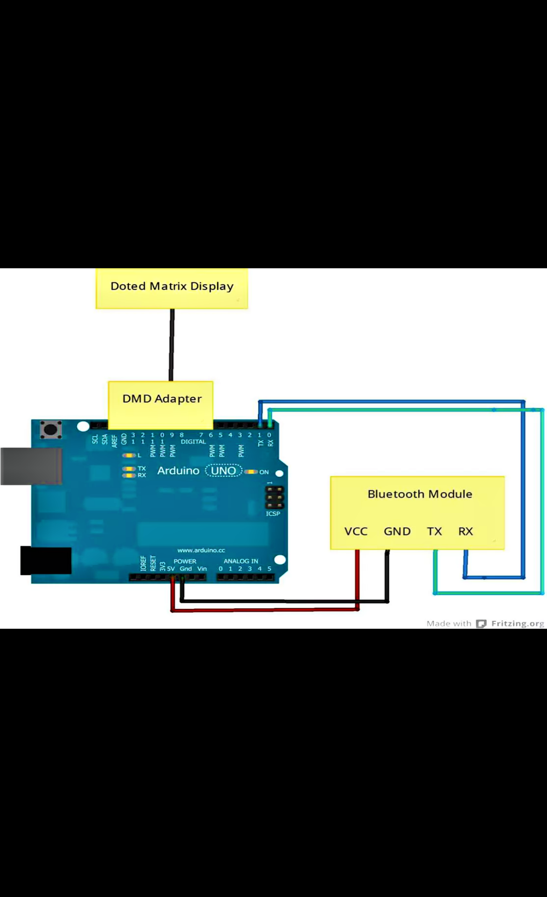

**Figure3.2** Interfacing Arduino UNO with HC 06 Bluetooth module

**FLOW CHART:**

Flow chart of processing,code execution at the receiver microcontroller and its synchronization with transmitter module

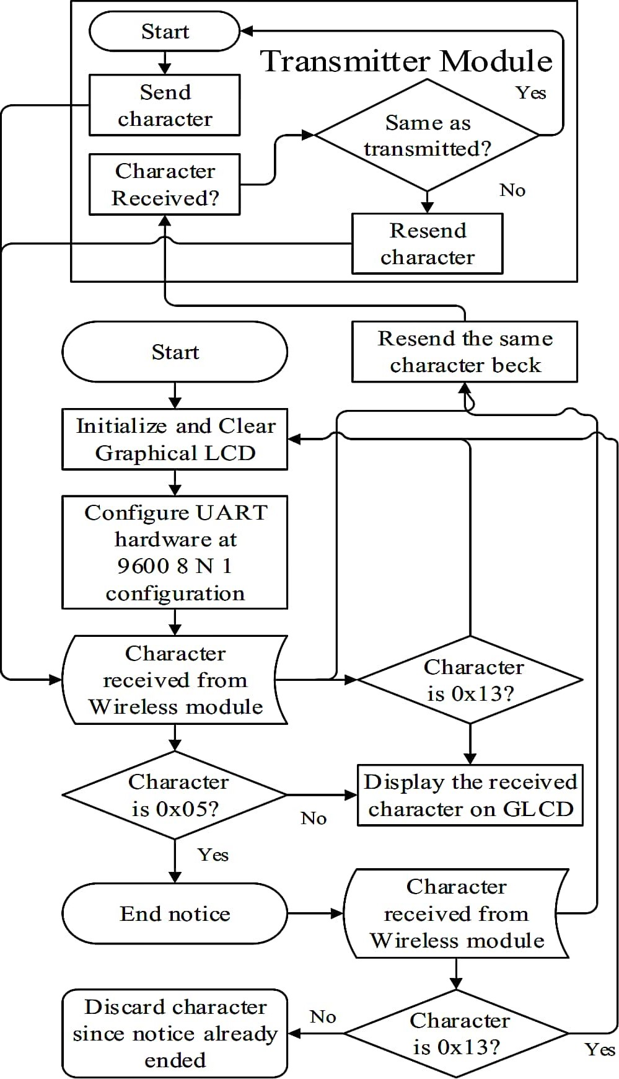

DMD

**Initialize and clear DMD**

**Figure 3.3** Flow chart of processing

**Flow chart of the Android application execution**

**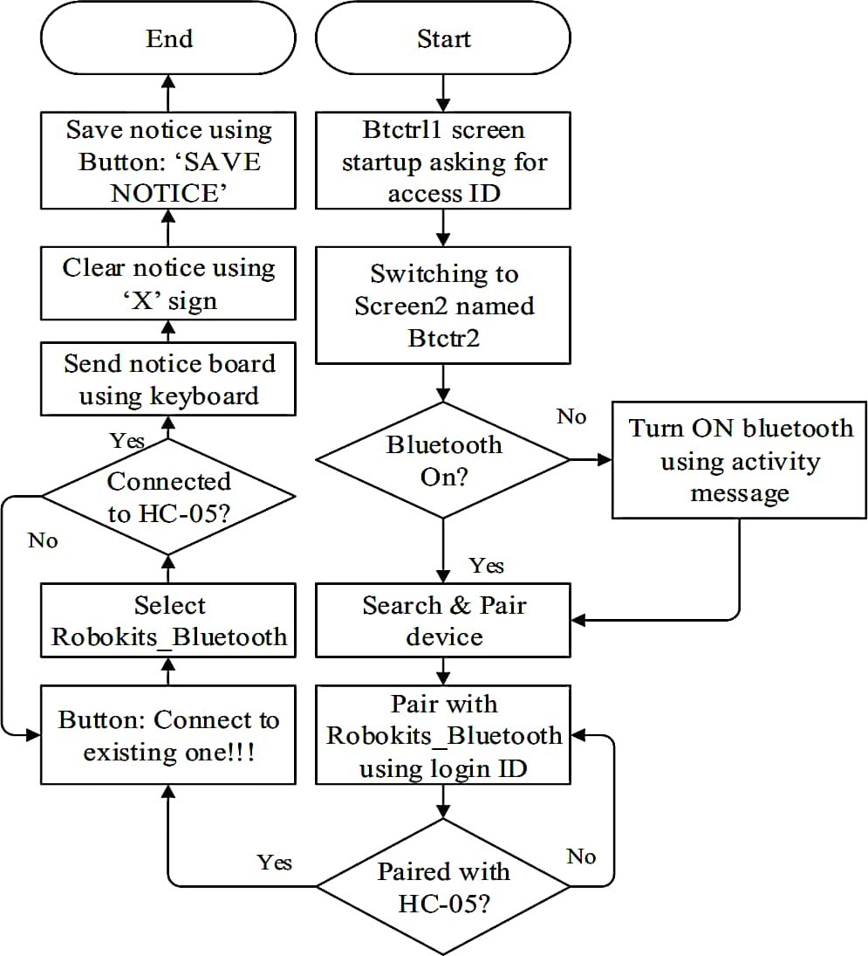Figure 3.4** Flow chart of the Android application execution

06

06

HC 06

HC 06

**CHAPTER 4:**

**ADVANTAGES**

* Save the environment by using paper free work
* Automatic system
* High efficient and less maintenance
* Prevents unauthorised accesss
* No printing and photocopying costs
* Quick result
* Real time operation
* It is easy to operate and less power consumption
* Portable
* No printing and photocopying costs.

**APPLICATIONS**

* It is useful in hospitals, colleges,airports, official areas.
* It is used to display the information wirelessly in public areas like, bus stations, railway stations,organisations,airports etc.
* Used in restaurants,hotels to welcome the customer’s.
* Advertisement in shopping malls.
* Organizations
* Managing traffic in metropolitan cities and other public utility places.

**CHAPTER 5:**

**RESULTS AND CONCLUSIONS**

**5.1 TESTS AND RESULTS:**

Dot matrix display is a matrix of led connected in 32x16 pattern. we can wirelessly transfer messages over mobile to DMD using Bluetooth.32x16 DMD display board having 512 LEDs. We have to show a message on the board. We connect a HC06 Bluetooth module to Arduino UNO and connect DMD display to Arduino UNO using ribbon cable as shown in the circuit diagram provided. Take the Arduino UNO and download Arduino IDE software for the purpose of coding. Next connect USB to arduino UNO and pc. Then open arduino ide software in pc and upload the sketch or program to Arduino UNO. Next open Bluetooth controller,the android application then search,pair,connect to Bluetooth module .Then communication will be established. In bluetooth controller app several options are appears on the screen.Click on terminal ,type your message which you wants to display and click sent button. It will show on your DMD display board and scrolling starts automatically. In this Project I am going to discuss about "How can you make a scrolling display using the arduino and control it through smartphone" . By using the Bluetooth you can send maximum 63 characters and through the program it can display up to 500 characters . The message from Bluetooth is temporary and it will automatically clear if the micro-controller is turned off.

**5.2 CONCLUSION**

Traditional notice boards uses paper work.But day to day changing these boards is very difficult task and a waste of time. One digital system is used for many applications.At present most of the electronic boards are designed with a wired system and not suitable for portable applications.To save the environment by paper free work,to save the time,to enhance the accuracy this system is needed.Most advanced features are used for best working of the unit.With the help of growing technology the project has been designed,implemented and tested successfully.

**5.3 FUTURE SCOPE**

* We can add feedback system in Android app. So that user can get feedback of the action.
* We can implement security to prevent unauthorised access so that any other person can not control the system.
* Addition of voice control feature.
* Able to extend the range of communication by the use of IOT.

**BIBLOGRAPHY**

**BOOKS:**

* Electronics for u
* The art of electronics

**WEBSITES:**

* **[www.electronics](http://www.electronics) for u.com**
* **Create.arduino.cc/project hub.**
* **www.circuitdigest.com**
* **www.projectsof8051.com**
* **www.gadgetronics.com**
* **www.engineersgarage.com**

**APPENDIX - A:**

**RS-232 STANDARDS**

One of the advantages of a serial system is that it lends itself to transmission over telephone lines. The serial digital data can be converted by modem, placed onto a standard voice-grade telephone line, and converted back to serial digital data at the receiving end of the line by another modem.

Officially, RS-232 is defined as the “Interface between data terminal equipment and data communications equipment using serial binary data exchange.” This definition defines data terminal equipment (DTE) as the computer, while data communications equipment (DCE) is the modem. A modem cable has pin-to-pin connections, and is designed to connect a DTE device to a DCE device.

**PIN ASSIGNMENT:**

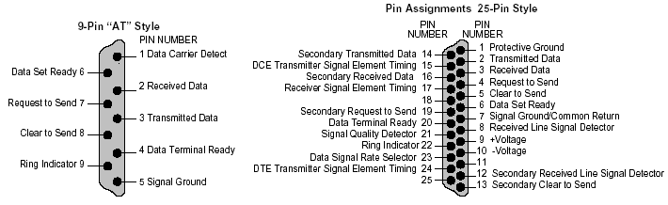

**Figure A1:**Pin Assignment

**DB9 CONNECTOR:**

The term "DB9" refers to a common connector type, one of the D-Subminiature or D-Sub types of connectors. DB9 has the smallest "footprint" of the D-Subminiature connectors,and houses 9 pins (for the male connector) or 9 holes (for the female connector).DB9 connectors were once very common on PCs and servers. DB9 connectors aredesigned to work with the EIA/TIA 232 serial interface standard, which determined thefunction of all nine pins as a standard, so that multiple companies could design them into theirproducts. DB9 connectors were commonly used for serial peripheral devices like keyboards,mice, joysticks, etc. Also they are used on DB9 cable assemblies for data connectivity.

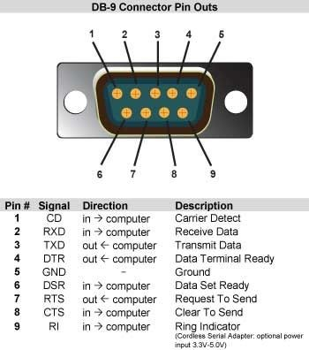 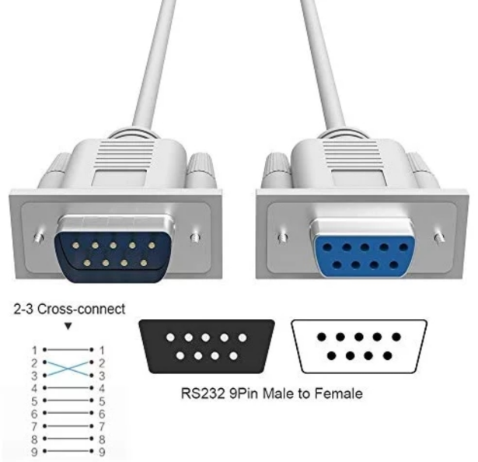

**Table A2:DB9 Pin details Figure A2:**DB9 Connector

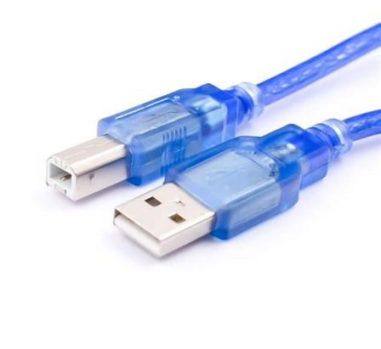

**Figure A3:**USB to serial Cable

* It is used to connect arduino UNO,Mega,Nano,Duo etc.
* USB 2.0 Male A to Mini B 5-pin cable.
* Arduino Cable is used for programming the Arduino board.
* This is also used as power supply.
* This allows us to connect Arduino board with Computer.
* The data transfer rate is 480Mbps.

**APPENDIX-B:**

**MAX-232**

**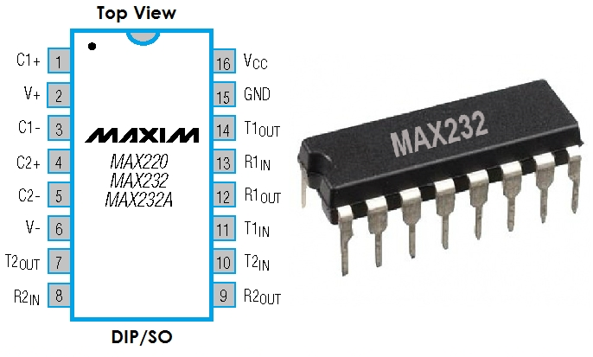**

**Figure B1** MAX - 232

MAX232 ic is used for the serial communication between Microcontroller and GSMmodem. The MAX232 is an integrated circuit, first created by Maxim Integrated Products, thatconverts signals from an RS-232 serial port to signals suitable for use in TTL compatibledigital logic circuits. The MAX232 is a dual driver/receiver and typically converts the RX,TX, CTS and RTS signals.In interfacing GSM modem with microcontroller, the MAX 232 is used. The MAX232 device is a dual driver/receiver that includes a capacitive voltage generator to supplyEIA-232 voltage levels from a single 5-V supply. Each receiver converts EIA-232 inputs to5-V TTL/CMOS levels. Each driver converts TTL/CMOS input levels into EIA-232 levels.The MAX 232 chip is used to do the level shifting and this chip is required to send dataserially to a PC which requires voltage levels as per RS 232 standard.RS 232 is an electrical signalling specification published by the Electronic IndustriesAssociation (ElA). The 9-pin (DB9) connector, with specific pin assignments, is commonlyaccepted as "the RS232 connector or the serial connector. This standard interface providesconnection for only modest transmission rates & is often used with modems.

**MAX 232 CIRCUIT:**

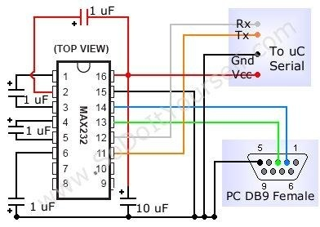

**Figure B2:** MAX - 232 Circuit

Mostly MAX232 used in 16-pin DIP package. it consist of 3 major blocks .It can only be powered by 5 volts to make it power supply compatible with most of the embedded systems. First block is the voltage doubler in this ic switched capacitor techniques is used to make the voltage double .Once the voltage is doubled second block will converts that voltage to +10 and -10. The third block consists of 2 transmitters and 2 receivers which actually convert the voltage levels.

**VOLTAGE LEVELS:**

|  |  |  |
| --- | --- | --- |
| **RS232 Line type and Logic level** | **RS232 Voltage** | **TTL Voltage to/from MAX 232** |
| Data RX/TX Logic 0 | +3V TO +15 V | 0V |
| Data RX/TX Logic 1 | -3V TO -15 V | 5V |
| Control Signals Logic 0 | -3V TO -15 V | 5V |
| Control Signals Logic 1 | +3V TO +15 V | 0V |

**Table B3:** Voltage level of MAX232

**APPENDIX-C:**

**PROGRAM TESTING AND DEBUGGING USING ARDUINO**

**IDE TOOL**

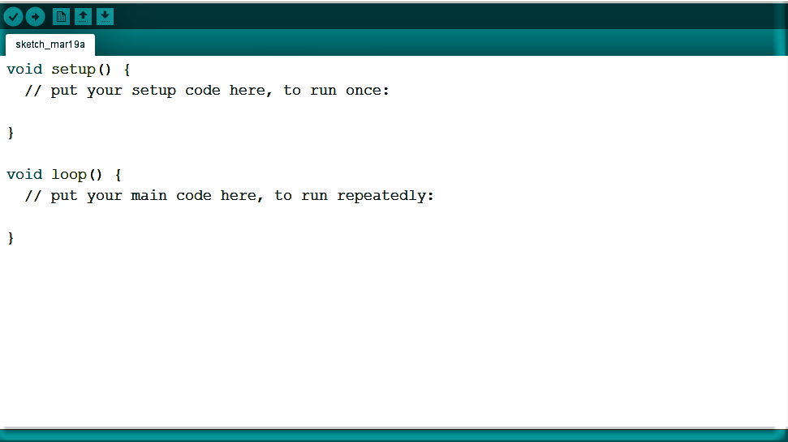

**Figure C1:** Creating New Project

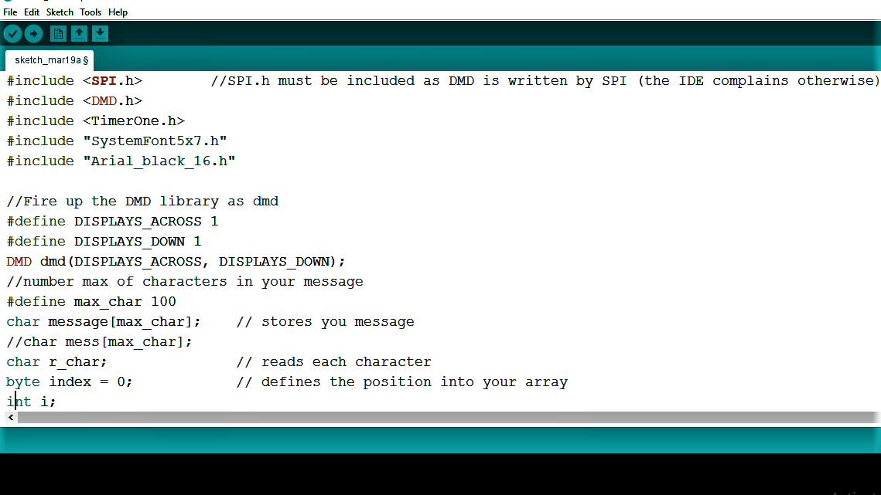

**Figure C2:**Project code

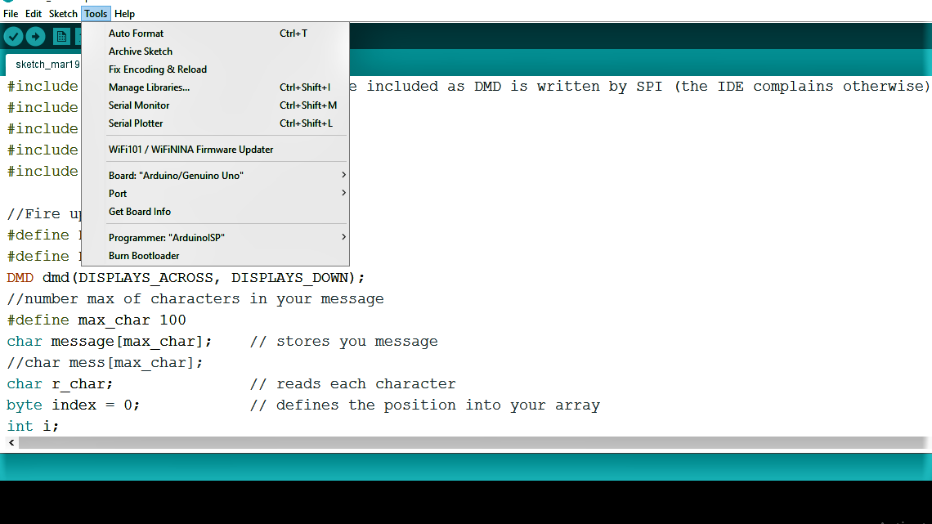

**Figure C3:** Configuration

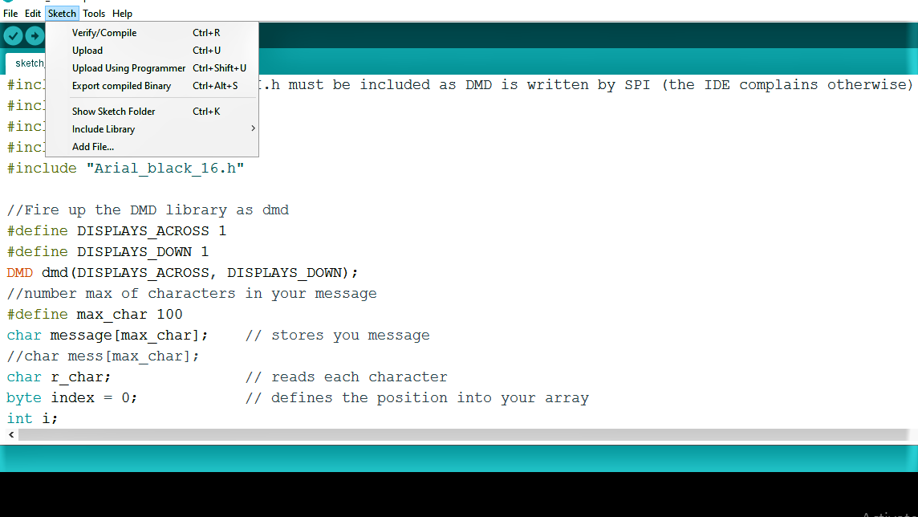

**Figure C4:** Loading Zip.library , Compiling, Uploading

Geting started with Arduino IDE

1. Download arduino ide softeware
2. Open arduino ide in your system
3. click on file, click on new, write the project code or load dot ino file

4)To addexternal liberary as mentioned in your programe, click on scketch, include liberary,add zip liberary and seect requered dot zip file

1. Connect your arduino board to system using cable
2. Click on board , select arduino uno/ genuino uno
3. Click on port and seect the usable port
4. Make the programer as arduino ISP
5. Click on verify/compile
6. Upload the program

**NOTE : You cant upload the program while Bluetooth is connected to the Arduino .**

**SNAPSHOT**